Introduction to Database Systems

Google Internship Program

Database Schema

Team Number: 8

**Team Members:**

**Ahmed Tarek Abdel-latif 1190157**

**Ali Mohamed Aly 1190223**

**John Maurice 1190403**

**Joseph Ameer Aziz 1190052**

**Contact Info:**

**Joseph Ameer -** [**joseph.aziz02@eng-st.cu.edu.eg**](mailto:joseph.aziz02@eng-st.cu.edu.eg)

**Ali Mohamed -** [**Ali.Hashish001@gmail.com**](mailto:Ali.Hashish001@gmail.com)

**Ahmed Tarek -** [**ahmedtarek1754@gmail.com**](mailto:ahmedtarek1754@gmail.com)

**John Maurice - johnmaurice71@gmail.com**

**9-1-2022**

**1- The New ER diagram:**

1. **Attributes**

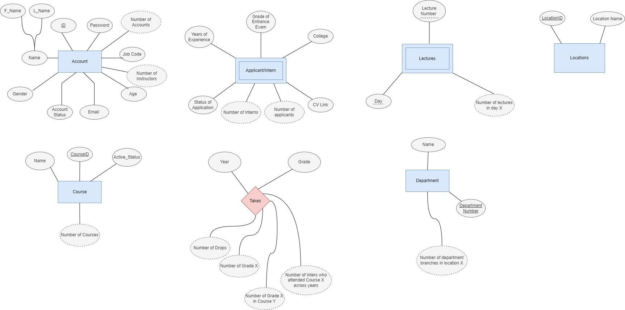

1. **Relations**

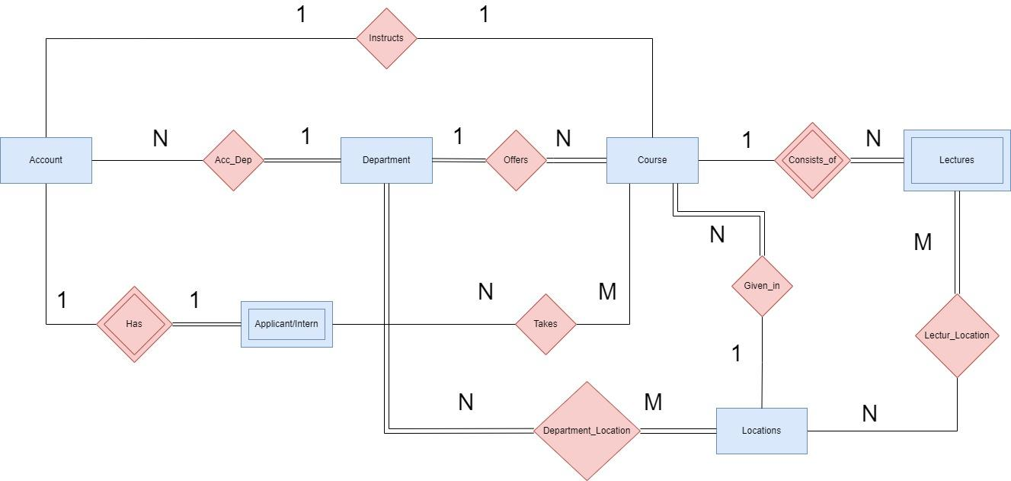

**2- Database Schema:**

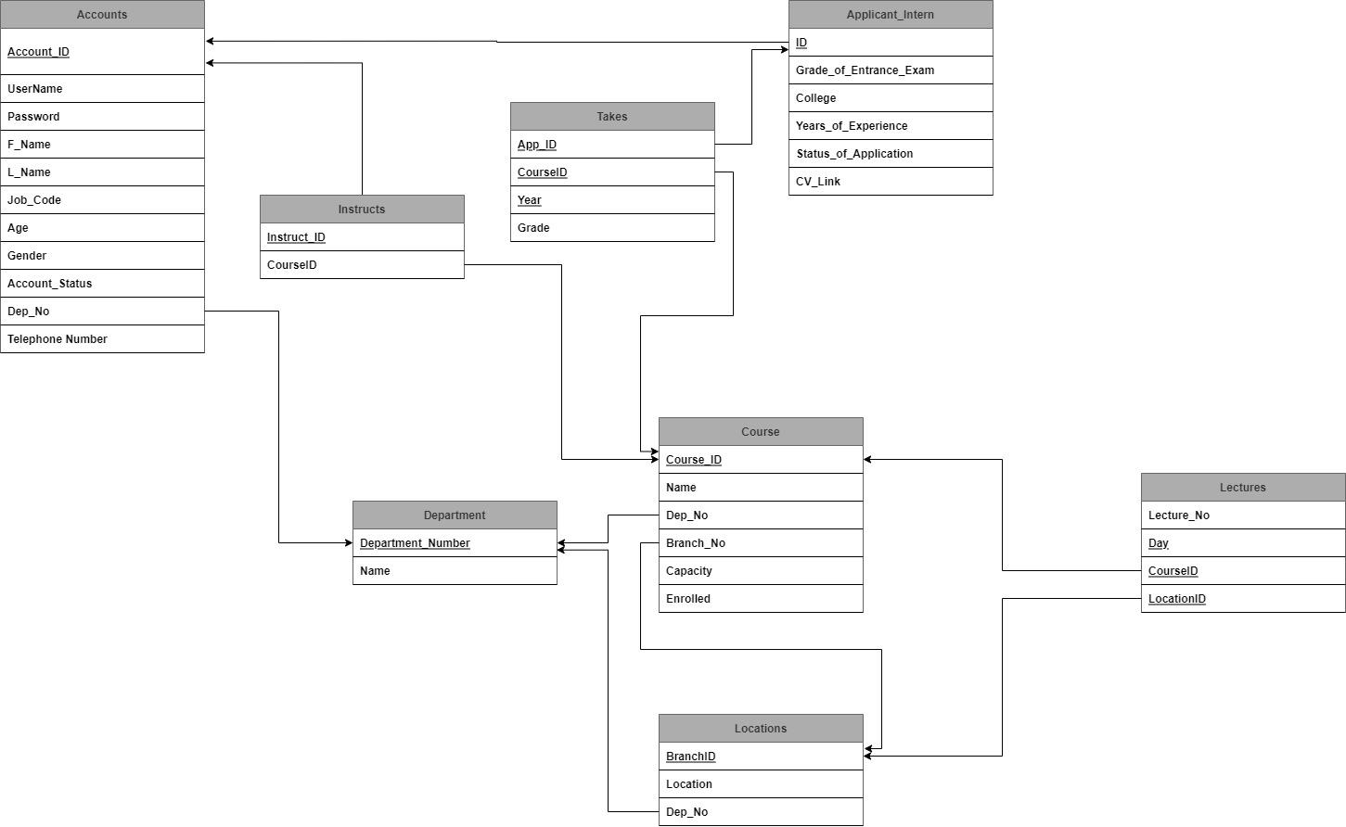

**3- Assumptions and Constraints:**

**Courses & Lectures**

- A course must be given by only one instructor and one instructor must give only one course but can give multiple lectures for that course.

- One course has multiple lectures.

- Courses can only be registered at the start of the year.

- Internship is not completed unless the registered course is passed, if the intern fails a course, it is still moved to the completed course table but with a failing grade.

- By the end of the year, the duration of all courses comes to an end, and the interns taking the course are assigned a grade.

- By the end of the cycle (year) all yearly activities such as grading must take place to allow for the new cycle to begin.

**Interns**

- Only one course can be registered per internship which lasts for a year.

- For an internship to be complete, the intern must pass the registered course.

- Intern can join only one department which offers that course.

- Intern has only one account.

- In order for an internship to be completed, Intern must pass the course exam and complete the training period in his department.

- After the internship has ended, the course taken is registered as complete.

- Withdrawing a course sets the grade of the course in the completed courses table to W and the intern becomes idle.

- A withdrawn intern automatically becomes an applicant and can’t apply to new courses in that year.

-When a new year comes, the withdrawn intern can apply again to the course.

**Applicants**

- Applicant is turned into intern if he passes the evaluation test (Entrance Exam) and his request gets approved by an instructor.

- Applicants can apply to multiple courses but only get accepted in one.

- Applicants can only have one account.

- Applicants can only apply for an internship at the start of the year.

**Department**

- A department may have multiple interns as well as instructors.

- Department provides a set of courses from which the intern chooses only one.

**Completed courses [weak]**

- One intern may complete several internships in different departments across years.

- Internship is completed once the course is passed, but it is placed in the completed courses table regardless of passing and failure.

- Once completed, you can’t apply for the same course again.

- Only the grade of the intern decides whether the course is passed or not.

**Department Instructors**

- The instructor can supervise/approve interns as well as accept/view/reject applicants.

- The instructor can only give one course but can give multiple lectures related to this course.

- The instructor is the one who assigns the grades of the interns.

- The instructors can generate statistics and view relevant data of applicants such as (count accepted applicants, department requested, courses enrollment requests) and interns such as (count of interns who completed the course/ withdrawn interns, grades).